SIMATS ENGINEERING
ASSESSMENT TOOL 1

COURSE NAME: OBJECT ORIENTED ANALYSIS AND DESIGN
COURSE CODE: CSA1102

COURSE OUTCOME COVERED
CO2: Design UML diagrams to represent system requirements and architecture.
(BL3)
Assessment Tool Weightage: 40%

QUESTIONS: Any 4 Total Marks:40

Annexure A

ANALYTICAL PROBLEM SOLVING

Code of Conduct:
I R.KAMALI(192521217) certify that this submission is my original work
and that I have adhered to the guidelines specified for this assessment.
I understand that any violation of academic integrity rules will result in disciplinary action.
Signature of the student:

Annexure A

ANALYTICAL PROBLEM SOLVING

3. Sequence Diagram Problem
In an Online Food Ordering System, a customer selects food items, places an order, makes
payment, and receives order confirmation. The interaction flow is unclear.
Tasks:
a) Identify objects involved in the process.
b) Define message flow between objects.
c) Represent activation and lifelines.
d) Construct a Sequence Diagram showing complete interaction flow.
(10 Marks)
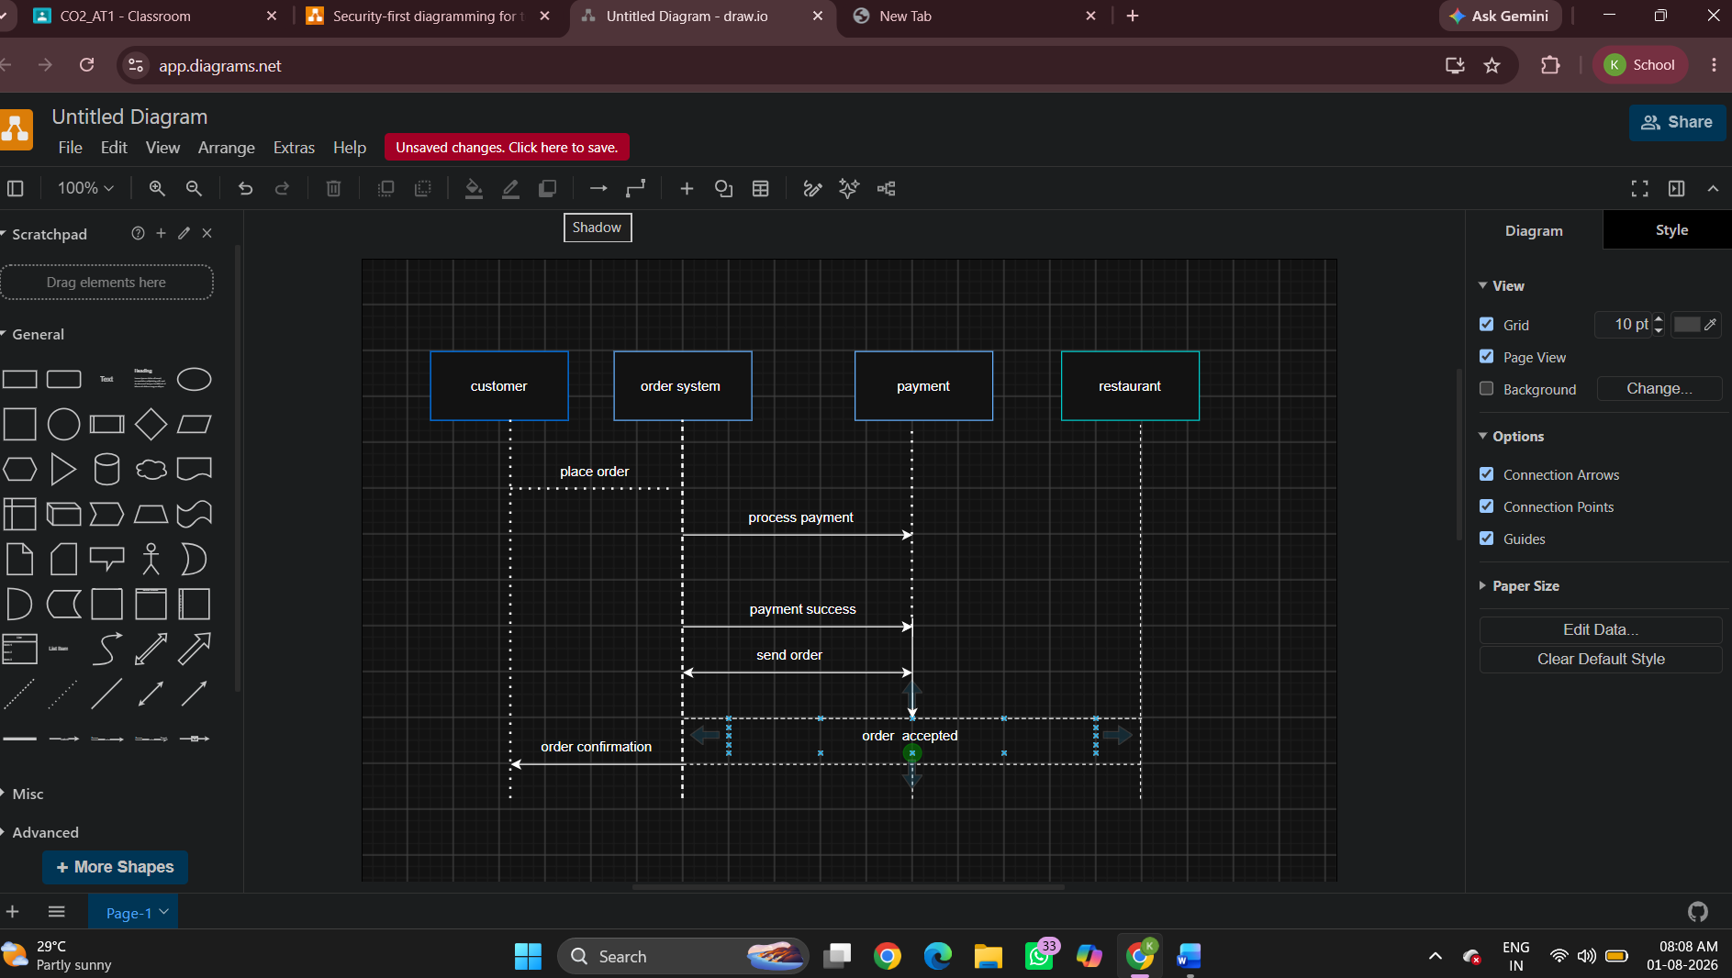

SIMPLE SEQUENCE DIAGRAM

